Caerphilly North
Neighbourhood Policing Team

Team Newsletter for

Ystrad Mynach, St Cattwgs & Hengoed Wards

February 26’ Meeting.



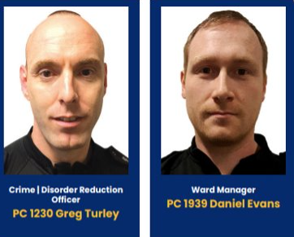

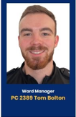

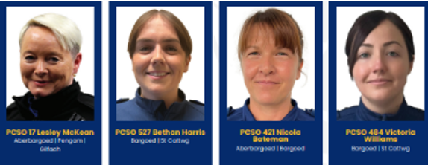



Bargoed & Ystrad Neighbourhood Team

Recorded Crime

Ward | December 2025 | January 2026 | +/-
Ystrad Mynach | 67 | 48 | -19
Hengoed | 34 | 23 | -11
St Cattwgs | 25 | 43 | +18

Overall, there has been a DECREASE in crime across the Ystrad and Hengoed wards. However, there has been an INCREASE in crime across the St Cattwg ward.

Recorded ASB (Nuisance)

Ward | December 2025 | January 2026 | +/-
Ystrad Mynach | 7 | 4 | -3
Hengoed | 3 | 3 | -0
St Cattwgs | 2 | 1 | -1

Overall, there has been a decrease in ASB across all wards.

Community concerns or patterns of note:

- Motorbike stolen from Penpedairheol – CCTV is currently being reviewing by officers to try and identify an offender.
- Vehicle crime in Hengoed is still ongoing however local officers and PCSOs have upped the patrols in the area to identify an offender and prevent further offences.
- Youths in abandoned building in Penallta. The owner of the building has been contacted and he advised he will come out and board up windows. This will hopefully prevent ongoing issues. PCSOs will also do regular patrols in the area.

Targeted Activity

- A Community Action Day was held in January which included targeted patrols at Ystrad Mynach College. Stop searches were conducted by PC2389 Tom Bolton. On a positive note no drugs were located.
- A Joint Operation was held on 28.01.26 with Trading Standards at Ystrad Town Centre. 500 illegal vapes seized.

- Due to the ongoing vehicle crime in Hengoed, an operation following the spike in vehicle crime during January is ongoing in the Hengoed Ward.

Engaged Communities

Our local PCSOs have been busy again during the month of January.
Some of the engagement pictures can be seen below.

PCSO 527, 202 and 539 held a local bike marking event.
A bike marking event run by the police is a community safety activity designed to deter bike theft and help recover stolen bikes.

- Marked bikes are less attractive to thieves because they are harder to resell.
- If a stolen bike is recovered, police can return it to their rightful owner much faster.
- Visible stickers or tags act as a clear theft deterrent.

PCSOs also did a local walk and talk for visible reassurance. Seeing police and councillors out together builds confidence that concerns are being taken seriously and not just discussed in meetings.

Some Pictures from these engagement events:

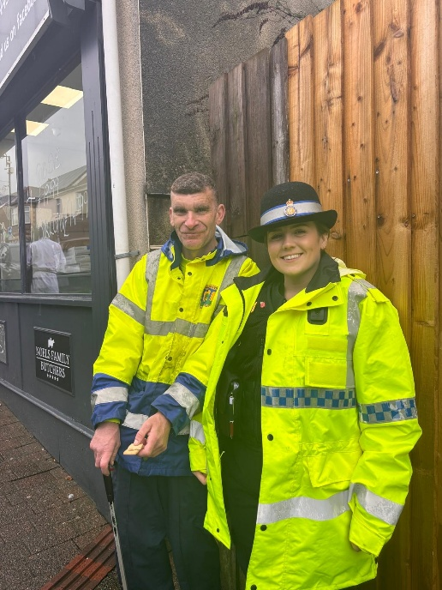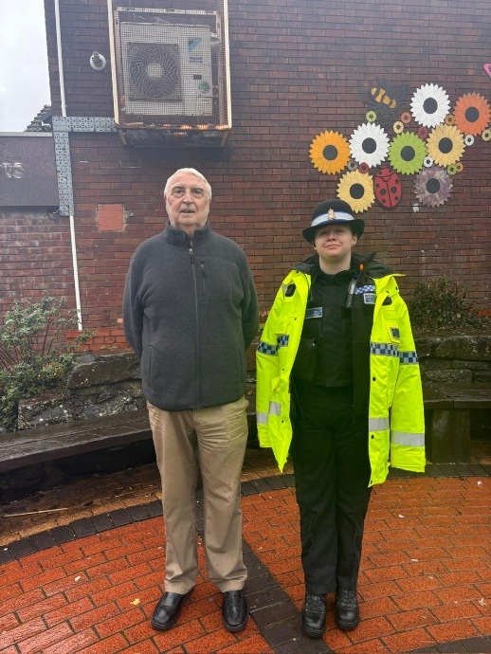

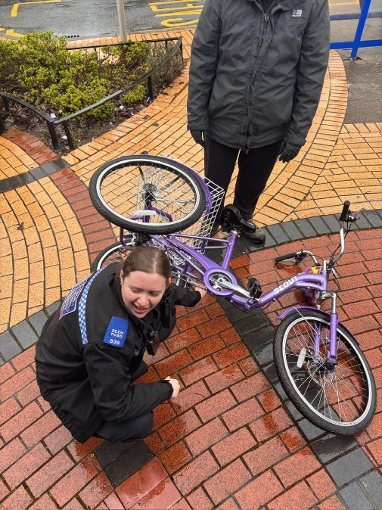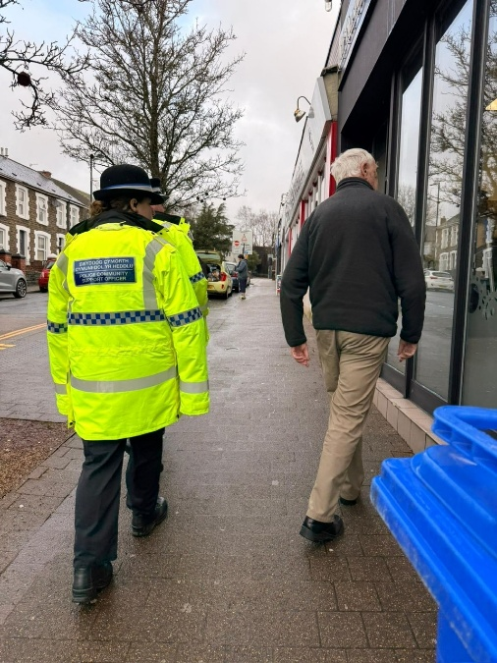

Upcoming Police Surgeries:

Gelligaer community centre:

24.03.2026 @ 17:30pm

Tesco, Ystrad Mynach:

11.03.2026 @ 14:00pm

Hengoed Train station:

11.03.2026 @ 13:30pm

The Caerphilly North Neighbourhood Team.

